

ME-330

ME 330: Mechatronics – Laboratory 2

Analog Open Loop Motor Driver

Nicholas Agtual, Dalaney Conte, Evaline Cuatok, Josh Gipson

Department of Mechanical Engineering

Spring 2021

**Abstract:**

This lab is intended to provide the student with a basic overview of analog open-loop motor control with ON/OFF control. Moreover, in this lab new components were introduced within the circuit like the op-amp, MOSFET, and a BJT. Circuits were modeled both physically and in Multisim but within the theoretical circuit a resistor was used to model the motor. This experiment also presented circuit analysis on analog systems. Two experiments were performed, one involving the MOSFET and one with the BJT and recorded the voltage and current through the circuit.

Table of Contents

1 Introduction and Objectives 5

1.1 Objectives 5

1.2 Required Components 5

2 Analog Open-Loop Motor Control: BJT 7

2.1 Simulated Circuit 8

2.2 Lab Questions: A 8

2.3 Physical Circuit 10

2.4 Lab Questions: B 11

3 Analog Open-Loop Motor Control: MOSFET 14

3.1 Simulated Circuit 14

3.2 Physical Circuit 15

3.3 Lab Questions 15

4 Conclusion 20

5 Appendices 22

6 References 23

List of Figures

Figure 1: DC Motor 5

Figure 2: LM324AN (quad op-amp) 6

Figure 3: MOSFET Transistor 6

Figure 4: BJT Transistor 7

Figure 5: Motor Controller (BJT): Simulated Circuit 8

Figure 6: Specifications for Power Output 10

Figure 7: H-Bridge 13

Figure 8: Motor Controller (MOSFET): Simulated Circuit 14

Figure 9: Voltage Across Neutral Motor 16

Figure 10: Voltage Across 100 Ω Resistor 18

List of Tables

Table 1: Base Current for Simulated & Physical Circuits 11

Table 2: Various Currents in MOSFET Circuit 15

Table 3: Recorded Voltages Across MOSFET with Motor On/Off 15

Table 4: Physical and Simulated Currents in MOSFET Circuit 17

Table 5: Physical and Simulated Values for, , and 19

Table 6: 2N2222 Transistor Gain (β) 22

Table 7: Datasheet for P30N06LE MOSFET 22

# 1 Introduction and Objectives

## 1.1 Objectives

The objective of the Analog Open Loop Motor Driver lab was to gain a basic understanding of op-amps, MOSFETs, and a BJTs. In addition to understanding the individual components, building the physical and simulated circuits displayed how the components can be used in practical circuits. Multisim, a circuit building software, was used to construct the simulated circuits and determine important values within those circuits. Since an open loop controller has no feedback and provides an output signal to the motor in our case. In the two experiments used different transistors were used and the differences were observed between the two transistors.

## 1.2 Required Components

**3-6 DC Motor**

Figure 1: DC Motor

DC Motors are powered by a combination of magnetism/electromagnetism and current. When current enters the motor, it passes through a coil in which a magnetic field is being applied. This magnetic force produces a torque which spins the motor. There are two terminals on the motor, and if the current becomes reversed by switching the wires at these terminals, then the motor will begin to spin in the opposite direction. DC motors can be represented as a resistor in series with and inductor [3].

**LM324AM Quad Op-Amp**

Figure 2: LM324AN (quad op-amp)

The LM324A Quad Op-Amp is the op-amp used in this experiment. The operational amplifier amplifies signals, and, in the case of this experiment, it amplified the DC voltage [2]. There are several configurations of the op-amp within the circuit to get a desired output or wave. Different configurations have different levels of impedance which we accounted for within our experiment. Within our simulated circuit our op-amp could use different amounts of voltage but in our experiment, there was a minimum voltage to make it operational.

**Transistors**

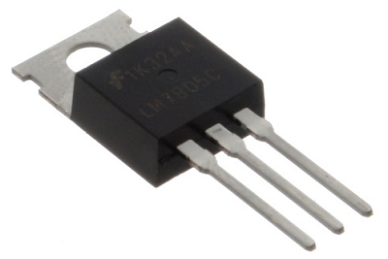

Figure 3: MOSFET Transistor

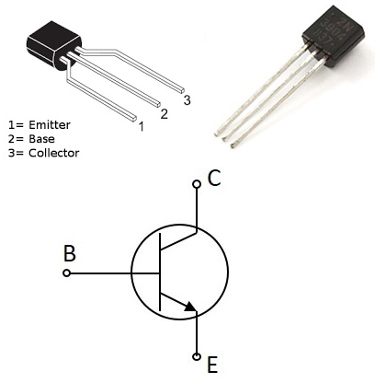

Figure 4: BJT Transistor

The key difference between the two circuits was the different transistors we used for each experiment. Both are transistors but they operate in different ways. The MOSFET is a voltage driven device, meaning the voltage provided at the gate terminal will determine how much current flows through the drain of the transistor. The BJT transistor is a current driven transistor which means that the current is altered. With a BJT the input and output current is similar but the output current may be multiplied by some factor associated with the BJT. MOSFETs are used in larger applications and since the BJT is current driven it is often used in more simplified circuits [2].

# 2 Analog Open-Loop Motor Control: BJT

Bipolar junction transistors also known as a BJT are semiconductors that has “three adjacent regions of doped silicon, each of which is connected to an external lead” [2]. These three leads are the base, collector, and emitter. Current accumulates and is collected by the collector and is emitted by the emitter; all the current flow is controlled by the base [2]. BJTs can act in three regions. The three regions are the cutoff region, active region, and saturation region. In the cutoff region, which occurs in this motor controller when the switch is open, the collector current is 0. When the transistor is in the saturation region, which occurs when the switch is closed in this motor controller, the motor experiences a current and can be activated. The transistor used in this analog open loop motor driver is a 2N222 NPN transistor.

## 2.1 Simulated Circuit

The simulated motor controller using the BJT was constructed using Multisim (See Figure 5). The value of the resistor in parallel with the diode represents the DC motor’s resistance. This value was measured to be .

Figure 5: Motor Controller (BJT): Simulated Circuit

## 2.2 Lab Questions: A

Find the datasheet for the 2N2222 transistor, the power output of the ELVIS breadboard. Review the specifications and retain the datasheet for the appendix of your lab report (do this for all parts you look up). Specifications will show you the pin-out locations for devices such as the base, collector, and emitter on the BJT and op-amp.

1. **Determine the resistance to use for R1 to ensure that the transistor is in saturation mode. To ensure that the transistor is in saturation mode, use KCL and KVL to determine what alternative value would be required for resistor R1. R1 should be a function of the load (motor RL). Note: RL in Figure 2 is the motor even though it is represented as a resistor.**

**HINT: The ratio of the collector current to the base current (hfe or 𝛃) is the transistor gain. has a range of values. Should you select the larger or smaller value in the range? The voltage between the collector and emitter (VCE) = 0.2 V and the voltage difference between the base and emitter (VBE)=0.7 V. Write down the equations you derive from these hints and use them in your lab report.**

Using Equation 1, Equation 2, and Equation 3, the minimum value of R1 can be determined. represents the transistor gain and is equal to the ratio of the collector current to the base current. From the 2N222 transistor data sheet, the gain value ranges from 35 to 300. Knowing that and , the value of R1 can be determined to be using the smaller value of .

|  |  |  |
| --- | --- | --- |
|  |  | Equation |
|  |  | Equation |
|  |  | Equation |

In this case, with R2 being the resistance of the motor, which is , and being 5V, R1 becomes 137.33.

1. **Calculate the current drawn from the base terminal of the BJT.**

Using Equation 2, and plugging in and , the current will equal 19.5mA.

1. **Determine how much current is passing through the load, . Verify that the transistor can support this current from the specifications.**

Using Equation 3 and plugging in , , and , the base current will equal 1.11A.

1. **Look at the specifications for the power output on the ELVIS board. What is the maximum output for the 5V supply?**

Figure 6: Specifications for Power Output

The output voltage for our ELVIS board is within 5% of our expected 5V. Since To derive the power of the system we must multiple the voltage by the current to get the max power and this can be seen in Equation 4.

|  |  |  |
| --- | --- | --- |
| ´ |  | Equation |

Thus, the maximum power we could obtain from our board would be 10.5 W.

1. **If the current exceeded the limit, what do you think would happen?**

If the current exceeds the limit, the transistor will then behave in the cutoff region instead of saturation. This means that it will behave like an open switch.

## 2.3 Physical Circuit

The physical circuit is constructed using all the components mention in the required components section. The BJT transistor in this circuit acts as a switch for the motor. One challenge when constructing the physical circuit was the use of the momentary push button. Prior to constructing it, it was not clear which terminals where connected. Once the pushbutton was placed between one of the bridges on the breadboard, the issue with the pushbutton was eliminated.

## 2.4 Lab Questions: B

1. **Compare the simulated current with the measured currents. Discuss the differences in this section of your report. Think of some reasons why they might be different.**

Table 1: Base Current for Simulated & Physical Circuits

|  |  |  |
| --- | --- | --- |
|  | **Simulated Circuit** | **Physical Circuit** |
| **BJT Base Current (Motor On)** |  |  |
| **Collector Current** |  |  |

The base current is slightly higher than the base current of the physical circuit as expected. This is mainly since all components are assumed idea in the simulated circuit when they all have some inherent resistance and tolerances. This is a viable source of difference. The collector currents show a much higher deviation. The simulated collector current is about 17.5 times larger than that of the physical circuit. This is because the DC motor is only modeled as a single resistor, where a real DC motor is an inductive load in series with a resistive load. Equation 5 substantiates this claim. The motor’s resistance also becomes much more complex when the motor is running.

1. **What advantage does the transistor have over just using the physical switch in its place?**

The transistor has many advantages when compared to a physical switch especially in the case of the circuits constructed in this lab. The main advantages of using a transistor over a physical switch is two-fold. The first advantage is the mechanisms of activating the switch. Different transistor can be triggered via sound, light, electrical signal, radio signal, and more. Physical switched are limited to the manual input of the user. The method of activation not only allows for more freedom but increases the speed of switching. By automating this process, the switching process becomes much faster. In addition to speed and activation, the switch carries more noise within the system. Moreover, there are fewer moving parts with a transistor than a switch and that affects the quality of the component. These reasons make the use of a transistor over a physical pushbutton switch more desirable [3].

1. **Why is the diode included in this circuit? (Use the internet to learn about flyback diodes).**

By nature, diodes only permit the flow of current in one direction [1]. In the case of the analog open loop motor controller with the BJT, the transistor is acting as a switch. When the BJT enters the cutoff stage, current does not immediately prohibit current from flowing through the motor. This is called a voltage flyback spike. The use of a flyback diode prevents this current spike in the motor by allowing the charge to dissipate.

* 1. **What could happen if the diode were not included (do not test this, just explain)?**

A DC motor can be modeled by a resistor in series with an inductive load. Without the flyback diode, the motor would experience a huge voltage spike. This would cause harm to the motor, potentially destroying it [3].

1. **Could we design a circuit with transistors that make the motor spin in both directions? What would this design be?**

DC motors can change the direction of rotation based on the polarity of the voltage source (3). The polarity is dependent on how the current flows through the motor. One circuit design that can be used to reverse the direction of rotation in the H-Bridge configuration (See Figure 6). The H-Bridge consists of four transistors and two voltage sources.

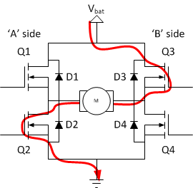

Figure 7: H-Bridge

Depending on the combination of which transistors are actuated, the current can flow from the positive to negative terminal of the motor, from the negative to positive terminal, or can restrict current from flowing through the motor. It consists of four transistors and two voltage sources

1. **Write a response for the current across the load in terms of the input voltage for when the button is pressed. Model the loads as an inductor, I, and a resistor, R, in series. Assume saturation mode.**

When the switch is open, the flyback diode is in forward bias, meaning it is permitting the flow of current (2)). This means that the BJT is in the cutoff region and the current into the collector is 0. When the switch is closed, the flyback diode is in reverse bias, and there is a voltage across the load, which in this case is being modeled by a resistor and inductor in series (3). The current can be found using Equation 5.

|  |  |  |
| --- | --- | --- |
|  |  | Equation 5 |

represents the saturation voltage which is .2V.

# 3 Analog Open-Loop Motor Control: MOSFET

The Metal Oxide Semiconductor Field Effect Transmitter or MOSFET is a type of Field Effect Transistor that contains three electrodes: the gate, the drain, and the source. Any change in the gate voltage can either decrease or increase the current through the drain. The MOSFET operates in two regions: the active region and the saturation region. In the active region, voltage at the gate controls the current flowing from the drain to the source. In the saturation region, current remains the same even if a gate voltage is applied [4]. The MOSFET that is used in this circuit is the P30N06LE MOSFET transistor.

## 3.1 Simulated Circuit

The simulated circuit utilizing a MOSFET shown in Figure 8 was created using Multisim. To be represented on Multisim, the motor was replaced by a 100 Ω resistor as a proxy. Using Multisim we were able to measure the current through the motor as well as the current through the gate when the motor is on and off. Additionally, we were able to find , , and when the motor is on and off. These values can be found below in Table 2 and Table 5.

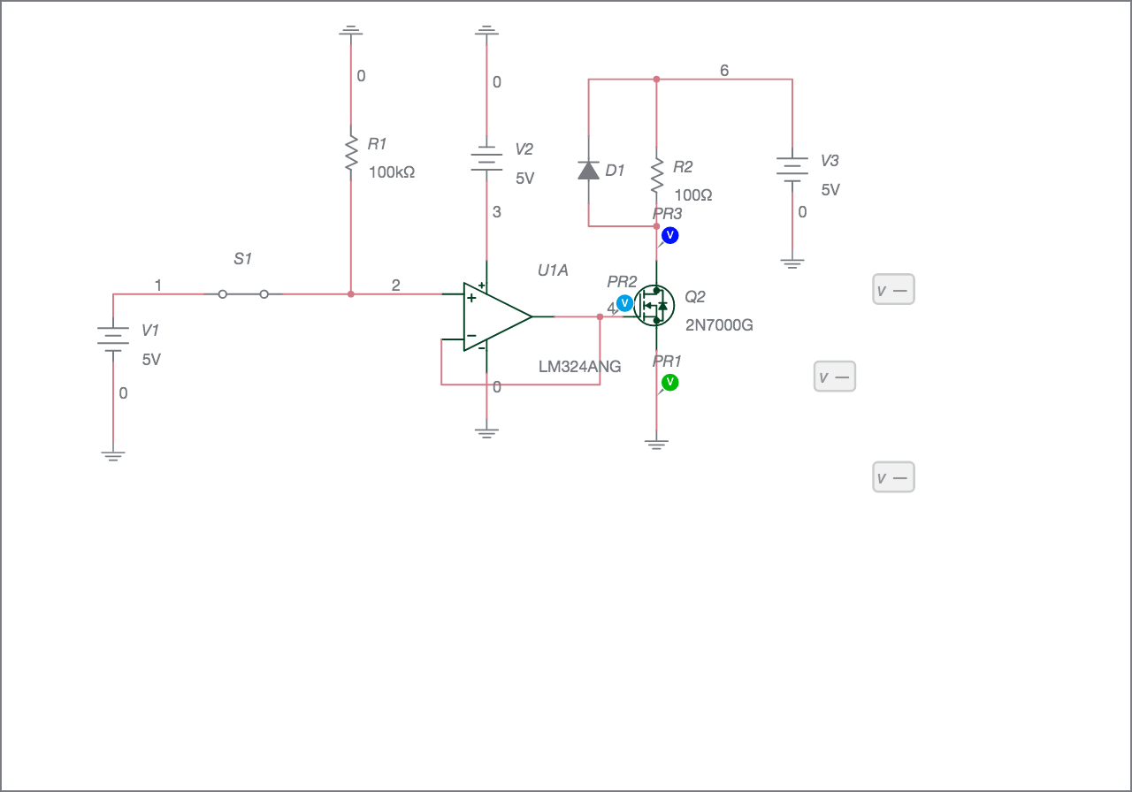

Figure 8: Motor Controller (MOSFET): Simulated Circuit

## 3.2 Physical Circuit

Due to the similarity of the circuit in both parts of the lab, wiring the second circuit was relatively straightforward. The main component that changed between the two was the transistor that was inputted. In this circuit a P30N06LE MOSFET was used and the 220 was removed from the connection between the op-amp and the transistor. After the circuit was completed, the current across the motor was measured as well as through the gate when on and off. Values for , , and were recorded as well and can be seen in the tables below.

Table 2: Various Currents in MOSFET Circuit

|  |  |  |
| --- | --- | --- |
| **Motor Current** | **Gate Current (On)** | **Gate Current (Off)** |
| 0.1387 A | 0.4121 mA | .009 mA |

Table 3: Recorded Voltages Across MOSFET with Motor On/Off

|  |  |  |
| --- | --- | --- |
| **Voltage Location** | **Motor On** | **Motor Off** |
|  | 0.146 mV | 17.7 mV |
|  | 1.61 mV | 8.41 mV |
|  | 9.87 mV | 4.967 V |

## 3.3 Lab Questions

1. **Look up the datasheet for the MOSFET and determine if its operating characteristics are valid for this circuit.**

According to the specifications listed in Table 7, the P30N06LE MOSFET is valid for the circuit. The maximum allowable ratings for the voltage across drain to source and drain to gate is 60V. The gate to source voltage allows for a range from +10V to -8V. Comparing these values with the voltages found across the pins in Table 3, the transistor is within range to operate.

1. **Calculate (resistance of the motor when it is running) from the motor’s current and . How does this compare with the measured resistances?**

The measured , which is the voltage across the drain portion of the transistor and the voltage being supplied to the resistor was 4.9667 V as seen in Table 2. By dividing this value by the current through the motor while it was running which was 0.13865 A, the resistance in the motor is calculated to be . As seen in Figure, the resistance across the motor when disconnected from the circuit was recorded to be .

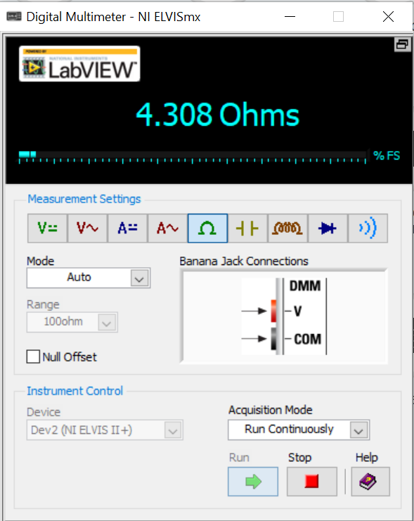

Figure 9: Voltage Across Neutral Motor

In the simulated circuit a resistor was used as a proxy to represent the motor and later as well in the physical circuit, even though the true value is one that is much smaller. This is done to prevent rapid heat generation across the resistor and burns. The differing resistance value that was recorded across the motor could be due to not measuring the motors resistance once it was wired into the circuit and running. The measurement is much higher than the expected resistance of the motor.

1. **Compare the simulated current with the measured currents. Discuss the differences in this section of your report. Think of some reasons why they might be different.**

The simulated currents and measured physical currents can be seen in Table 4.

Table 4: Physical and Simulated Currents in MOSFET Circuit

|  |  |  |  |
| --- | --- | --- | --- |
|  | **Motor Current** | **Gate Current (On)** | **Gate Current (Off)** |
| **Physical Circuit** | 0.1387 A | 0.4121 mA | .009 mA |
| **Simulated Circuit** | 44.07 mA | 3.526 pA | 15.51 fA |

The differences in the current for the motors can be explained due to the differing values of resistance between the components used. Since a resistor was used a proxy for the motor, it is providing a much higher resistance and limiting the current across the component. Both the physical and simulated currents across the gate are both approximately zero. Since the simulated circuit represents values in ideal conditions, the numbers closely approach the true value which is zero. A MOSFET is voltage driven meaning that it is not dependent on an input current to function. This concept checks out with the currents measured in both the simulated and physical circuits.

1. **What is the purpose of R2 in Figure 4?**

The equivalent resistor that is referred to in Figure 4 is R1 in Figure 8. This 100k resistor functions as a pull-down resistor within the circuit. By wiring to ground, the resistor limits and controls the amount of current that would eventually flow through the transistor when the switch is closed.

1. **Is this transistor operating in the ohmic region? Describe why or why not.**

The ohmic region is when a transistor’s drain current has a linear relationship with changes in the drain-source voltage. If the transistor was in the cut-off region there would not be any current flowing through it. In saturation, the current will not change even if the gate voltage is altered [4]. If the voltage was changed within this circuit, there would be a proportional change to the drain current.

1. **Compare the measured for the 100 Ω resistor and motor. Explain why they are similar or different.**

As seen in Figure 10, the voltage measured across the 100 Ω resistor was measured to be 4.9455V.

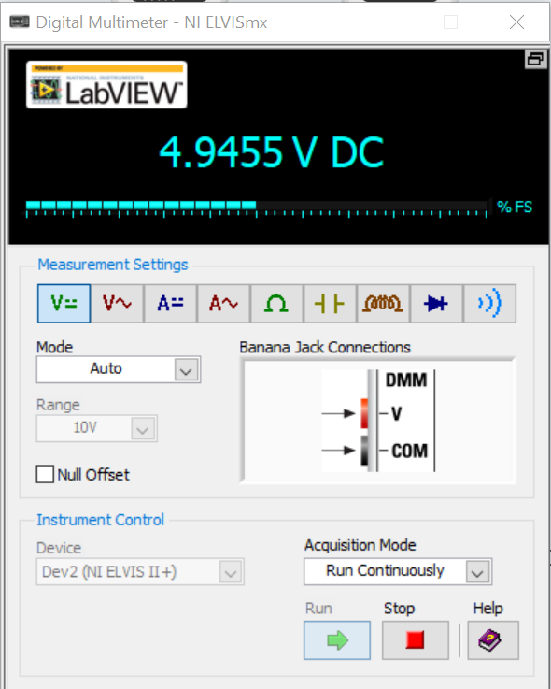

Figure 10: Voltage Across 100 Ω Resistor

With a current measured of 0.04970A the of the resistor is calculated to be 99.51 Ω. This value is close to the expected value and the error between the two can be attributed to the resistances of the wires in the circuit as well as the other components. These results can be compared to the of the motor which was calculated to be which was noticeably higher than the measured resistance of 4.08 Ω. The differences between the two components varies greatly between the expected value and the value measured.

1. **How does each measured compare to the value in the specifications?**

According to the specifications given in Table 6, is .047 Ω. When compared to the measured value of 99.51 Ω and 35.82 Ω for the resistor and motor respectively, there is a remarkable difference between the values.

1. **Do the measured values for , , and when the motor is on and off make sense? Why or why not?**

The simulated and physical currents for , , and can be found below in Table 5.

Table 5: Physical and Simulated Values for Vss, Vdd,and Vg

|  |  |  |  |  |  |  |
| --- | --- | --- | --- | --- | --- | --- |
|  | **(on)** | **(off)** | **(on)** | **(off)** | **(on)** | **(off)** |
| **Simulated** | 0 V | 0 V | 529.36 mV | 5 V | 3.5246 V | 15.528 mV |
| **Physical** | .146 mV | 17.7 mV | 9.87 mV | 4.967 V | 1.61 mV | 8.41 mV |

When comparing the simulated values to the physical values, the difference between them is not too large. Despite the differences in value between the physical and simulated values, this could be explained because the components such as the resistor are not exact like the components in the simulated circuit are. The measured values do not make sense because when the motor is off, the voltage of the drain is approximately 5V. However, when the motor is on the voltage of the gate should be approximately equal to 5V.

1. **In this lab, we used a buffer amplifier (op-amp). Is the buffer necessary? Why is it used?**

The buffer amplifier is necessary for this lab in order to ensure that the signal from the second circuit does not affect the signal from the first circuit. The gain of a buffer amplifier is one meaning that the magnitude of the input signal will remain the same, but it is useful because it allows us to connect the signal to another circuit without interference from the output circuit on the input circuit. This can work because the buffer amplifier has a very high input impedance but a very low output impedance. Thus, current through the output will not affect the current through the input [5].

1. **What are the limitations of an open loop controller?**

An open loop controller results when feedback from the output to the inverting input is absent in an operational amplifier [5]. In open loop controllers, the input can affect the output, but the output cannot affect the input. This is a limitation because if the output is affected for any reason such as noise or disturbances, the system cannot correct itself. Additionally, without the feedback, open loop controllers are very instable and unreliable.

1. **In this lab we did not control the speed of the motor, but we will in later labs. How is speed controlled in a DC motor?**

The speed in a DC motor can be controlled by changing the input voltage of the motor [6].

# 4 Conclusion

Completion of the Analog open Loop Motor Driver resulted in a better understanding of op-amps, transistors, and DC motors. Building both the simulated and physical circuits allowed for a deeper comprehension of how these components function together and their real-world applications. Troubleshooting occurred only with the physical circuits and how to properly wire the switch and positioning the op-amp on the breadboard. The switch functioned better once it was placed with the channels across the divider between the terminal strips. The observations made during the physical build corroborated the theory behind the differences between the two transistors used. The BJT circuit was current-driven and the base currents were extremely similar between the base currents measured in the simulated and physical circuit. However, difference arose with the collector current with a value higher in the simulate portion. In the MOSFET circuit, the currents across the pins measured closely between the two circuits, but the main source of error was due to the value of the motor resistance. Despite the differing results the lab was completed and analyzed successfully.

# 5 Appendices

Table 6: 2N2222 Transistor Gain (β)

Table 7: Datasheet for P30N06LE MOSFET

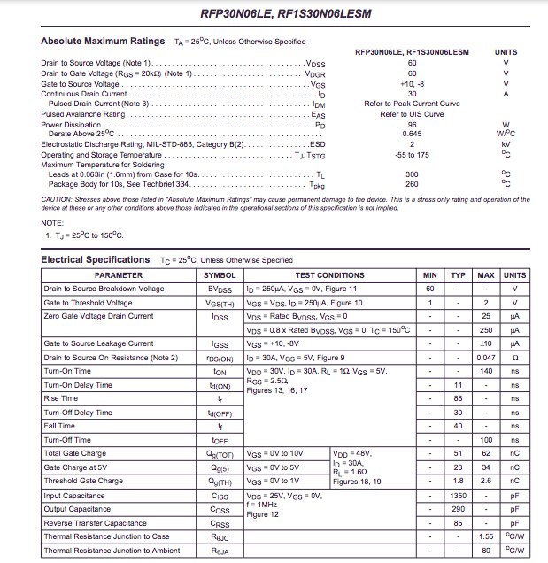

# 6 References

1. Escalona, L. “Electrical Circuits and Components.” ME 330 – Mechatronics. San Diego State University. Lecture
2. Escalona, L. “Analysis of Electrical Networks.” ME 330 – Mechatronics. San Diego State University. Lecture
3. Escalona, L. “Sensors and Actuators Used in Mechatronics Systems.” ME 330 – Mechatronics. San Diego State University. Lecture
4. Escalona, L. “Semiconductor Devices: The Field Effect Transmitter.” Me 330 – Mechatronics. San Diego State University. Lecture
5. Escalona, L. “Operational Amplifier Configurations.” ME 330 – Mechatronics. San Diego State University. Lecture
6. Escalona, L. “Electric Motors.” ME 330 – Mechatronics. San Diego State University. Lecture